SHORT STOPS FALL 2014

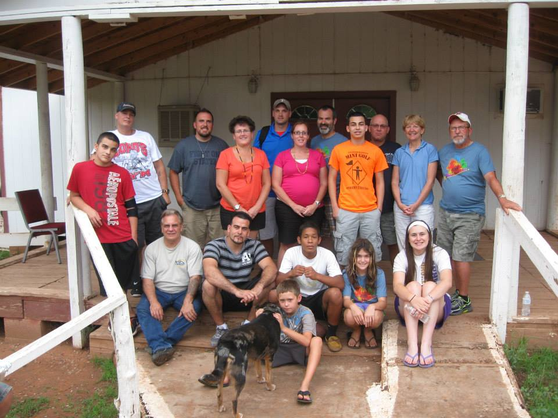Ephrata Grace & Akron Grace, PA -A group of 19 people from House of Blessings-Ephrata, Akron Grace and Ephrata Grace traveled to Whiteriver, AZ in July 2013 to serve on the Apache Reservation with AIM. Most of us, plus a few new members, returned in July 2014. We partnered with Riverside Church to help with their ministry to children. We held VBS for the children for two hours in the afternoon. We also presented a women’s retreat two mornings while we were there. We volunteered at a pregnancy center, sorting clothing and painting. Pray for Pastor Tina and her congregation at Riverside Church as they face many difficult circumstances. The suicide rate on the reservation is very high as are alcohol and drug addiction. The people feel they are without hope. Pray that we planted seeds of the hope we have in Jesus with the people in Whiteriver.

Ashland Bethany EC -My name is Rachel Stankiewitch and within the past year I've had the opportunity to take two trips to Guatemala (in March and in November)  to do mission work with Gospel Rooted Ministries. The first trip I took was with a group of students from my college (Carson Newman University) and the second time was with another Carson Newman student. During my time in Guatemala I was able to visit various parts of the country to spread the gospel and work on service projects. Most of these projects included hosting vacation bible schools at the elementary and middle school levels, delivering water filters, constructing a small church, building stoves, and preparing a fish farm. I also had the opportunity to speak at church services, women's bible studies and in schools, sharing my testimony and what it means to be a follower of Christ. Gospel Rooted Ministries is a fantastic ministry that I hope to do more work for in the future. The love and support I receive from friends, family and church family is a wonderful representation of Christ's love. I'm so blessed to have them supporting the opportunities God lays before me. (photo)

Manheim Trinity E.C. sent a volunteer group of young men to Twin Pines Camp for a Mini-Mission Work Trip.  During the four day June 2014 trip, the group painted outside equipment and cleared a trail for vehicle access to a remote area.   The group worked independently to assist in the preparation for the Summer Season of campers.   This annual trip has allowed Twin Pines personnel to be free for other projects needed at the Camp. *– Lauren Gochnaurer* (photo)

Harrisburg Trinity EC, PA: The Trinity youth group took a group of 14 to Manassas, VA to serve in Group's Week of Hope from June 22-27, 2014. .  During this week, we served by working with kids in summer camps, volunteering at homeless shelters, beautifying local parks, and volunteering in nursing homes.  Also, God met with our group in amazing ways during this week and all of us had life changing experiences that we will remember forever! - *Ryan Martin*

Zion E.C. Church, Myerstown, PA - On April 23 I left Myerstown to travel to The E. C. Church of India located in the city of Churachandpur, Manipur in the north east region of India. This would be my fourth trip in 14 years to the first of our International conferences. The initial purpose of the trip was to accompany Dr. Ken Miller as he was to present the Evening addresses to the 43rd Annual Leadership Conference. My presentations were to focus around meeting with leadership and addressing the ECT our College\Seminary in Churachandpur. When Dr. Miller was not granted a timely visa my responsibilities then included the Conference also.

Meetings with the leadership helped to cement relationships established over the last few years as well as to be able to see the work accomplished by the work team of 2013. I saw the wall they constructed and heard stories of the relationships built through the seminars held for the women during the wall construction.

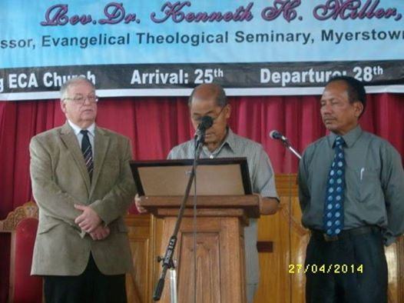 I would be remiss in not mentioning Rev. Angam. Pictured on the right next to Elder Gante the chairman of ECCI, he is the General Director (Bishop of ECCI). He spent time touring me around and getting me from place to place. He also helped to provide many new insights as we built better relationships as brothers in Christ. These relationships will hopefully lead us into a stronger church here and abroad. -*Rev. David Swift*

Bethesda EC at Reedsville - A team of eight - Pastor Jeff and Tasha Byerly, Steve Minnich, Sara Stoyer; Doug, Kirby and Tristan White; and Connie Wright - traveled to Belem, Brazil, from July 24 to August 5 to minister with David, Conce and Andrew Roof. Despite challenges in getting to their destination the Lord enabled them to arrive just one day late! The congregation at the Icoaraci Church welcomed them warmly and provided the base for outreach. About 70 children participated in a special "Happy Day" event, similar to our VBS. Then, youth and adults attended a three day English camp, provided by the team. While appreciating the sights, sounds and tastes of Brazil, the team would probably say that the best part of the trip was the relationships they formed with the Brazilian people. Thanks to the Roofs for their wonderful hospitality! – *Connie Wright* (photos)

Amy Babb has been an active participant in the ministry of Youth With A Mission during 2014. In January she began discipleship training at YWAM's Texas facility and then served in New Orleans and Panama. After a short visit home to PA in June, Amy returned to YWAM Texas, where she is attending the School of Evangelism and will eventually minister in Detroit and Mexico.

Faith E.C. Church,Temple, PA - Hi my name is Tammy Schaeffer. My youth group and I went on a mission trip in 7/2014.  We went to Blue Knob, PA, right outside off Altoona with an organization called Team Effort.  The youth group, Andy Becker and I were working on the home of a widow and her brother. Some of things that we worked on were:  we tore down the back porch and started building another one, we put primer on the outside of the house and we redid her garden in the front of house.  This was a very trying week for my group; not only did we deal with some accidents we also had to deal with the death of a loved one of our youth leader.  The youth worked so hard to get the back porch completed and to tear down the walls.  We did not get the back porch done but we managed to get pretty far on it.  The one project we did get done was the new garden in the front of the house.  I had the pleasure of watching God work thru my youth and how satisfying that was to my heart.  We shared lots of sweat and tears that week; however there was lots of laughter too.   The youth that went were Connor Becker, Tyler Becker, Owen Schaeffer, Trevor Schaeffer, Catherine Green, and Brandon Bogoniewski.   On a side note the youth group did fundraising and raised all the money on their own. (photos)

Ebenezer E.C., Brownstown, PA - Justine and Austin Eldridge and Ben Imhoff from had the privilege to serve with Big Creek Missions in Kentucky.  They were part of the work team from Mohns Hill.

California EC, Morgantown, PA -The youth had a great experience with Christian Endeavor’s Life Builders Work Camp in New Jersey this July. We worked on home repair projects for families in Atlantic City whose houses were damaged during Hurricane Sandy.  We hung drywall, taped. spackled, sanded, painted, and put in tile and laminate flooring. In the evenings we enjoyed worshipping with other youth groups and studying the Bible along the theme of "Strong in the Storm."  Mark 6:50

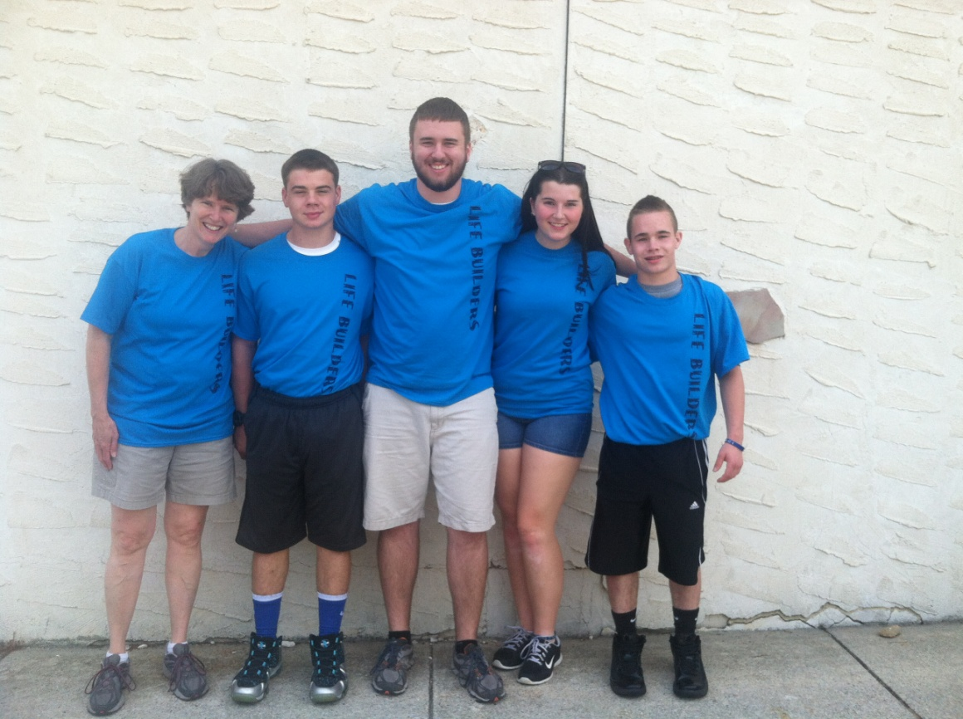

Sinking Spring Community E.C., PA – Lori Koons, a nurse, served at a camp for orphans south of Moscow in late June-early July. Agape Unlimited promotes health and shares God’s love through medical assistance to those who have little or no access to health care. There were 34 children served at the camp.

🡺Three youth served as counselors at Twin Pines camp this summer; Joshua Kuipers, Kaitlin Price, and Jason Price. This was the first year for Josh and Jason, but Kaitlin had served before.

🡺Seven teens and four adults traveled to Dinwiddie VA for a GROUP work camp along with over 400 others from all over the nation. They ministered to local people through home repair and light construction projects. Among other things, the Community group built a number of wheelchair ramps and decks for secondary exits. 37 projects were completed in the week long session (July 27- Aug 3.) The team consisted of Pastor Matt Hill, Harold Wheeler, Chip Hunter, Kathy Schultz, Sydney Schultz, Dana Schultz, Celah Hunsicker, Sammy Bentz, Corinne Hunsicker, Sarah O’Boyle and Cameron Brichta. (photo)

Ebenezer E.C. Church, Jim Thorpe, PA –Mary Jane Sterling and Dana Dunbar joined Pastor Marie Terry of Christ Redeemer Church on an evangelistic visit to Scotland (Dec. 23, 2013-Jan. 3, 2014). Mary Jane is an accordionist and was able to play at various programs, including hospital visits and church services. They also did street evangelism and prayer walks. (photo)

First E.C. Church, Palmyra, PA – In June, Jay and Barbara Johnson saw their dream to take their family to Alaska on a mission trip come true at Victory Ministries of Alaska. The Johnson family’s “home” for 10 days was named Aspen Lodge and boasted 7 bedrooms with 3 toilets. The 13 family members shared their home with the most beautiful view anyone can imagine. One project that was assigned to the Johnsons was to finish siding, sand, and stain a large log cabin that needed much attention. It looked like an overwhelming project to us. But the family attacked the log cabin and after five days, all of Victory including ourselves, were astounded at the completion and beauty of the home. We were then given the task to sand and stain a 150 foot porch/deck attached to the conference center. The family worked together very diligently and tirelessly till completion of their projects. They also stripped, waxed, and buffed the huge dining room floor on their own whim. (photo)

At 5:00 a.m. on Saturday, August 2nd, 7 members of the Sonshine Praise Puppets, from Palmyra First EC, started on an 8-day journey to Joplin, Missouri.  At Joplin, they worked with the Boys and Girls Club spreading God’s Love by conducting an all-day VBS type program from 9am – 6pm Monday thru Friday. The puppeteers were tired by 6pm each day, but excited to be able to share God’s Word through singing, puppets and evangelizing to more than 200 children / youth.   Through this program, 90 students/leaders received Christ as their Savior for the first time or re-dedicated their lives.  Friendships were developed through this trip.   The team was showered with blessing after blessing on this trip; from travel mercies, to being part of children receiving Christ, to the new friendships they received, and for all the love and support they received to do this mission trip.

St. David’s E.C. Church, Weigelstown, PA - sent a work team of 13 youth and adults to Wycliffe Associates (WA) in Orlando, Florida. Wycliffe Associates is a ministry of Wycliffe Bible Translators. The team served from June 27 through July 4. The team performed tasks that assisted in the maintenance of WA property and facilities and organized materials for its English Language Learning ministry. They also visited the Discover Center of Wycliffe Bible Translators and toured the Jesus Film Project at Cru (Campus Crusade for Christ) headquarters.

Hope Community Church, Fogelsville, PA - sent a team to Punta Gorda, Belize to teach VBS, tutor students, and make friendships with the kids at the LOL Children's Home.  Over thirty children live at the home - all are either orphans, abandoned, or have been abused.  The kids range in age from 3 to 17.  In addition to spending time at the Home the team also traveled to San Felipe village where they spent an entire day teaching and playing with the kids of the village.    
One of the highlights of the week was building a ga-ga pit and introducing the game to the kids at LOL.  The team traveled from July 12 through July 20, and included Dawn Mengel, Doris Zellers, Megan Kulp, Drew Parry, John and Hailey Ilgenfritz, Chuck and Alisa Hardy, Joe and Suzi Siddons, along with Pastor Ken and Denise Kalisz. (photo)

Grace Community Church, Willow Street, PA - On Saturday, July 19, 2014, a team of nine left to serve at Camp LiWa in Fairbanks, AK. Over the next two weeks the team assisted camp staff with numerous jobs around the camp which allowed the camp’s staff to continue with their normal day-to-day camp operation tasks. The team also interacted with summer campers and counselors. Why participate on a work team? Said one LiWa staff member, *“I’ve been trying to get that job finished since October.”* God blessed the hearts of the team in many ways, He taught lessons in patience and flexibility and most important the opportunity to share His love with others. Members of the team were: Don and Diane Hess, Rick Hess, Kate and Laura Laukhuff, Heather Ranck, Dwayne Steager, Lindsey Ulmer and Denise Weidman. (photo)

This summer a six member team traveled to Dobreni Romania to serve at the Casa Ray orphanage. While there we conducted a Vacation Bible School program for the 20 children who call Casa Ray home. The Bible lessons focused on 2 Peter 1:5-6 and the children learned about prayer, brotherly kindness and knowledge. The children also learned how these characteristics could be seen in the life of Joseph and they concluded the lessons by performing a play of his life. A lot of time was also spent taking walks, baking treats, doing crafts and playing with the kids. (photo)

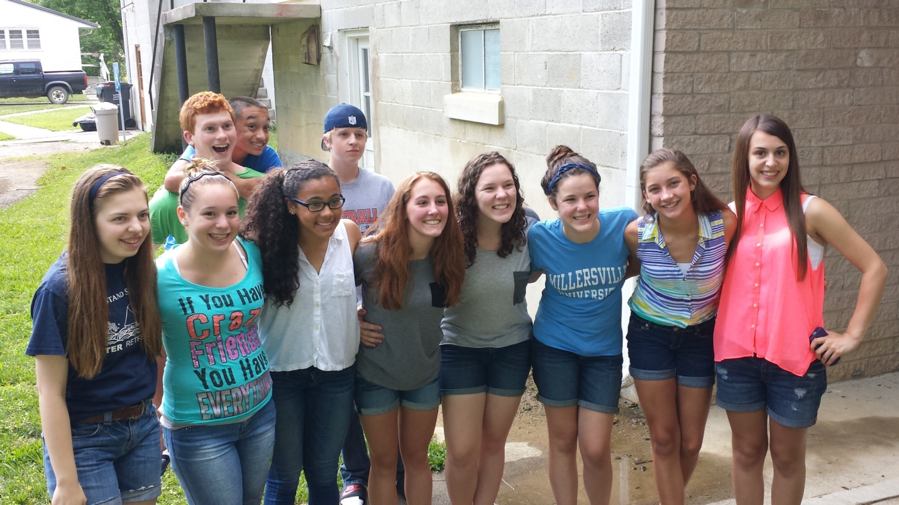

A team of 10 Students and 9 Adults from GCCWS served a mission week in Kentucky Appalachia, working to support the ministry outreach of our sister congregation, Canyon Falls EC Church. It was a very special week for each of the participants. During the week the team performed:

* Participating in the Sunday morning worship service by the students; Mike Hilt presented the morning message.
* Minor repairs/construction work on four homes in the community.
* Minor repairs at the Canyon Falls EC Church.
* Conducting a community outreach service on Tuesday evening.
* Conducting a fun night for youth in the church and community

The most special experience was one that was not originally in our plans, but God made a connection for this team to assist a senior, widowed female who was living in a broken down shack with her disabled son. She had no sink, no countertop or base cabinets, no cook stove, broken out windows and overgrown weeds and debris around the exterior of the shack. In spite of the horrible condition in which this lady and her son were living, she was full of the joy of the Lord; we never heard her complaining about these things; rather, she inspired all of the volunteers with her love for Jesus, our Lord and Savior, and her love for our team. What a BLESSING and INSPIRATION she was to all of us. The youth did a marvelous job cleaning up the exterior of the home. Base cabinets with sink and countertop were installed. Broken-out windows were covered with clear plastic to keep out insects, bats, etc.

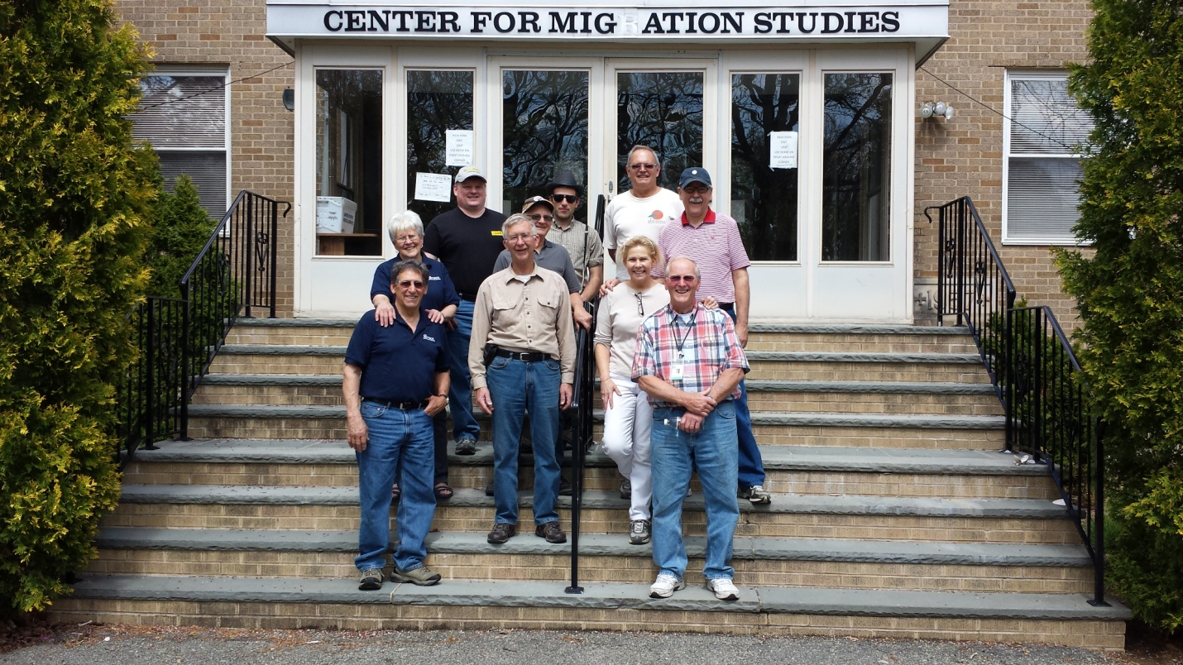

A crew of ten volunteers from Grace Community Church of Willow Street, spent a week (April 26-May 2) at the Mennonite Disaster Service Storm Aid’s Staten Island project, finishing the interior of 3 homes and partially finishing a 4th home.

Tasks included: installing, laminate and vinyl flooring, window & door trim and baseboards; installing kitchen and bath cabinets and countertops; and painting of the trim. We were blessed with a time of sharing with several of the families, including a family with a special needs child and another adopted, special needs child.

Trinity E.C. Church, Boyertown, PA - Jonathan Knier—Ethiopia,  MaryLee and Bill Boswell and Doug and Diana Smith—Ecuador, Week of Hope—Jr. High Work Camp Team, Christian Endeavor Sr. High Work Camp Team, Corinne Mancini—Malawi (photo)

On June 20th, seven of us from Trinity Boyertown traveled to Alcora, Spain to lead an English Camp for 64 kids. We joined Amy Friedlund, who had spent the prior 3 months doing an internship with Rachel and B.J. Whitaker. They had all spent the weeks leading up to English Camp doing a lot of advertising and preparation work. Our goal was to teach the kids some English, but mostly, it was to love them with the love of Jesus and introduce them to Rachel and B.J. Whitaker, who are living among them and want to have the chance to introduce their families to Jesus. While we were there, we also got to experience some really neat cultural events that helped us to appreciate and understand the Spanish people better. One of our most important jobs in Spain was our interactions with our host families. We pray that Rachel and B.J. will have an open door to continue a spiritual conversation with them, and eventually lead them to Jesus. – *Kathy Friedlund*

Trinity EC, Lititz PA - sent a team of 14 (Sr. High youth and adult leaders) to a Reach Workcamp in South Webster, Ohio from July 6-12.  The team helped paint, replace roofs, build decks and handicap ramps, and provide desperately needed repairs to numerous homes in the area.  If you would like more information about Reach work camps please contact Pastor Ryan Taylor at [logoyouth@gmail.com](mailto:logoyouth@gmail.com) or visit [www.reachwc.org](http://www.reachwc.org) (photo)