The conference support team (CST) has five areas of responsibility; Audit Committee, Church Center Operations Team, Conference Services Committee, Property Committee and Publishing Committee. The CST works closely with and depends on the Finance Committee, including Pastoral Compensation, and the EC Benefits Corporation to fulfill its mission.

The Executive Director will serve as the Chairman of the CST. Members include the National Conference Treasurer, Church Center Office Manager, Administrative Assistant to the Bishop and the Bishop is ex-offico. The Bishop and the chairman may appoint additional members who are to serve on the team.

Audit Committee – receives and reviews the audit of the National Conference financial records as well as the audit reports of all affiliated agencies and institutions.

Church Center Operations Team – encourage open lines of communication between staff members to discuss upcoming activities and tasks, building issues, job performance and personal issues.

Conference Services Committee – develops and implements the plan for the annual meeting of the National Conference. This includes the selection of dates and locations. The committee will establish a budget and set the conference registration fees sufficient to find the conference.

Property Committee – Responsible for the management, maintenance, repair and protection of all denominational property.
Publishing Committee – edit and publish the Discipline of the Church, the National Conference Journal, as directed by the National Ministry Team. It shall oversee other denominational publications as well as the denominational website.

The Finance Committee, chaired by the National Conference Treasurer, receives budgetary requests and prepares a budget that provides for the overall ministry of the National Conference. The budget and annual ministry fund rate are recommended to the National Conference by this committee. The Finance Committee members also recommend salaries and benefits for the Bishop, Executive Director, Associates, District Field Directors and Church Center Staff.

Pastoral Compensation duties such as recommending minimum annual pastoral salary increases and pastoral benefit levels have been assumed by the Finance Committee.

The EC Benefits Corporation manages and administers the employee benefit plans for assigned pastors and staff employed by the National Conference. Benefits available to active EC pastors and National Conference staff include health insurance, 403(b) tax deferred retirement savings plan, short term disability, workers compensation and a housing equity program.

For retired EC pastors two benefit plans are available a Medicare supplemental plan and the Manna Fund.

The administrative responsibilities of operating a church seem to be always changing and can absorb energy from ministry opportunities. The CST’s role in supporting and serving the church is to minimize the disruption of administrative tasks and allow the church to do what it does best; spread the saving Gospel of Jesus Christ and serve their local community.

The CST cannot and will not perform administrative tasks for churches. The EC Discipline and Rules of Conference do not allow the denomination to operate a local EC church. Local churches are responsible for their own operations. Nevertheless, the denomination does have an obligation to support churches. Successful healthy churches are pastor led with active supportive lay leadership. CST services are focused on areas that lay leadership should, but not always, have a larger role.

As such, the Executive Director and other members of the CST are available to attend church board/ministry council meetings or district meetings. It is expected that those meetings could be held on evenings and weekends. The CST members will make themselves available when necessary.

Other CST Services
- Pastor payroll calculation and tax withholding
- Non pastoral church staff payroll and employment issues
- Appropriation request
- Church property and liability insurance
- Housing and parsonage allowance demystification
- Proper recording of offerings and other charitable giving
- Policies and procedures to minimize the opportunity for fraud in the church
- Loan & Investment Fund
- Church budgeting
- Church property deeds
- Group 501(c)3 exemption
- Church by-laws and operating procedures
- Department of Labor regulation guidance

CST services are free of charge to the local church. The CST will not have the answer to every question however every effort will be made to find an answer. In certain situations professional paid assistance may be necessary and be strongly recommended.

Conference Support Team contact information

Kevin Henry – Executive Director
Office: 717-628-2171 or 1-800-866-7581, email: kenry@eccenter.com

Debra Patterson – Treasurer
Home: 717-871-1037, email: pattersondl56@verizon.net

Brenda Long – Church Center Office Manager
Office: 717-866-7581 or 1-800-866-7581, email: blong@eccenter.com

Jodi Earhart – Admin Assistant to the Bishop
Office: 717-866-7581 or 1-800-866-7581, email: jearhart@eccenter.com

Other Contact Information

David King, Benefits Administrator
Office: 717-628-1115 or 1-800-866-7581, email: dking@eccenter.com

Pat Wolfe, Church Center Receptionist and Purveyor of Publications
Office: 717-866-7581 or 1-800-866-7581, email: pwolfe@eccenter.com

Shirley Long, Church Center Business Office
Office: 717-628-1104 or 1-800-866-7581, email: slong@eccenter.com

Abigail Bomgardner, Church Center Business Office
Office: 717-628-1123 or 1-800-866-7581, email: abomgardner@eccenter.com

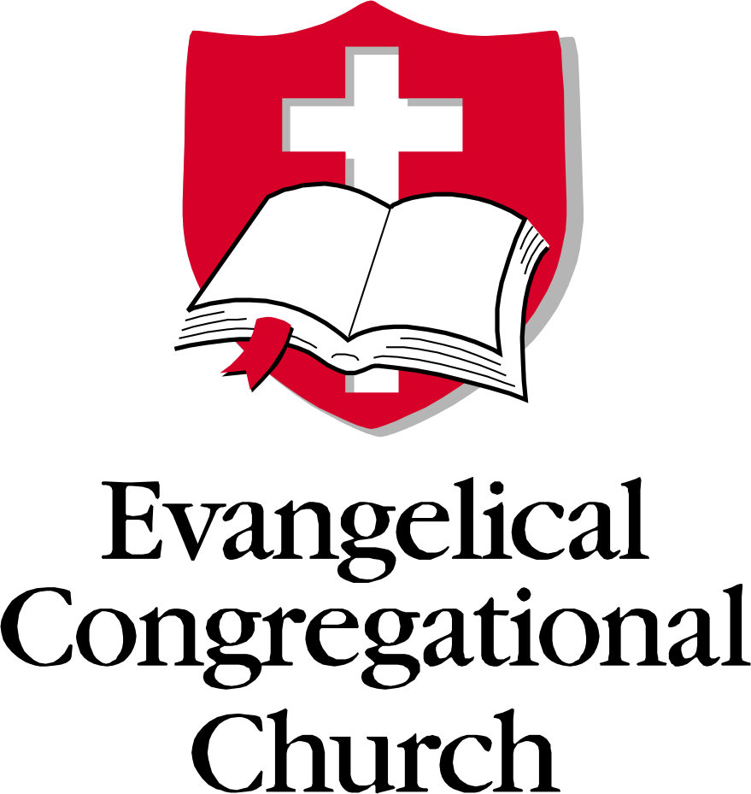

Conference Support
Team

The Conference Support Team will support the mission and serve the church by supervising our operations – stewarding assets and providing the necessary services to accomplish the mission across the network

